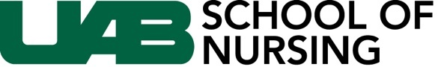

Faculty Position – Nurse Midwifery

The School of Nursing at the University of Alabama at Birmingham (UAB) invites applications and nominations for a full-time, nurse midwifery faculty position that aligns with the missions of the School of Nursing and UAB. Candidates for this faculty position must have current certification as a nurse midwife and be active in clinical practice. Certifications in additional advanced practice specialties are preferred. A minimum of 5 years clinical experience as a nurse midwife is required. Prior experience in an academic role and in leadership of a nurse midwifery program is preferred. Candidates must hold an unencumbered registered nurse license in the state of Alabama, or be eligible for licensure as a registered nurse in Alabama. Rank, tenure, and salary are competitive and commensurate with professional background and experience. Candidates must be doctorally prepared. This is not a remote position.

The School of Nursing’s legacy of leadership is focused on innovative programs of research, education, and clinical practice as evidenced in more than 18,000 alumni serving as expert clinicians, executive nurse leaders, deans and directors of nursing programs, nurse scientists, advanced practice registered nurses, and other professional leaders. The School is ranked in the top 10 percent of nursing schools nationwide by U.S. News and World Report and offers innovative baccalaureate, post-baccalaureate, master’s, post-master’s, doctoral, and post-doctoral programs.

For the complete position description, please visit: https://uab.peopleadmin.com/postings/18074

